20.6: Solving 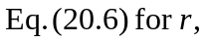
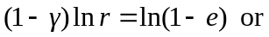
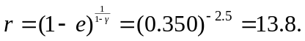
If the first equation is used (for instance, using a calculator without the 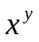function), note that the symbol “e” is the ideal efficiency , not the base of natural logarithms.

